WIUT - BSc (Hons) BIS
Information Systems Management Module

Seminar 3
Application of acquired knowledge.
Task 4: Review WIUT IS infrastructure

The campus of WIUT includes 3 teaching blocks (Istiqbol building, Amir Temur building and New building), a sports hall, a learning resource center (library), a lyceum building and 2 remotely located dormitory building.
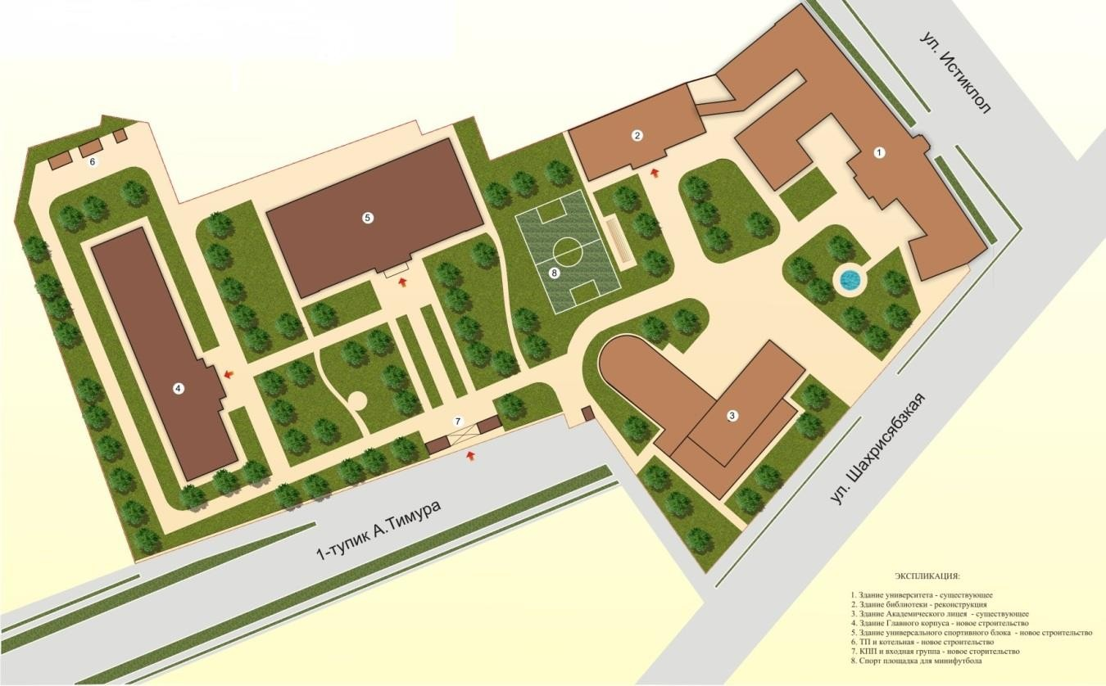
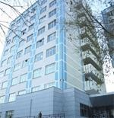
The operating teaching blocks contain administrative and academic staff offices, lecture and seminar rooms, PC rooms, 3 canteens, student social and learning spaces and other rooms. The learning resources center consists of a computer room and big 2-storey-reading hall and space for books storage. The University’s Wi-Fi Internet access covers all its area - all buildings and backyard.
Library
Sports Hall
‘Istiqbol’ building
Remotely located
Students’ Dorms
‘Amir Temur’
building
WIUT Lyceum
A New building
The University has an Information System (IS) to provide adequate IT services to staff and students.

Task 5: IS planning for extended WIUT campus in groups
Working in a group and using the best of your knowledge of WIUT IS services you need to provide your IS planning for the extended WIUT campus including the following:

Category/type of IS users - internal and external, and their IT equipment profile.
- IT/IS services provided in the campus for each category of users.

IT solutions to enable IS services.
Use ‘IS Service Inventory.xlsx’ template. Note that the contents of the tables are cross-linked. Each group focuses on a single IT service and presents finding.
Module Leader acts as an external expert to the groups.

Additional learning sources:
1. Introduction to IT infrastructure - https://www.youtube.com/watch?v=V6zJi8CU7Tk

